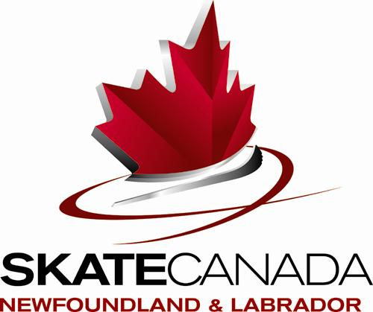

ANNOUNCEMENT

2018 Skate Canada Newfoundland and Labrador
SYNCHRONIZED SKATING CHAMPIONSHIPS

LOCAL ORGANIZING COMMITTEE: Prince of Wales Skating Club

DATE: March 2-3, 2018

LOCATION: Jack Byrne Arena, Torbay, NL

ICE DIMENSIONS: 200ft x 85ft

ENTRY FEES:
TWO SKATES (Elementary and higher teams): $325.00 per team + $33 per skater

ONE SKATE (Beginner I and Beginner II teams): $175 per team + $23 per skater

Registration includes a digital team photo.

ONLINE Registration:
Registration Opens: Friday, January 5, 2018 at 10:00AM
Teams must register and pay for Synchro Provincials online no later than Friday, January 19, 2018 at 5:00PM.
The link for registration is: https://skatenf.uplifterinc.com. See Appendix D for detailed registration instructions.
A list of entries and schedule will be posted online at as soon as possible after the closing date.

Note: Registration will only be accepted from teams registered with Skate Canada for the 2017-2018 season. Clubs/Team Managers are responsible to ensure ALL skaters and teams are registered with Skate Canada before completing online registration.

Sanctioned by Skate Canada NL
EVENTS TO BE SKATED: As per 2017-2018 SCNL Technical Package

MERCHANDISE:
Should the Local Organizing Committee offer merchandise, it will be posted in a second announcement and information will be emailed to clubs/team managers.

RULES:
Please note that the competition will follow the Synchronized Skating Eligibilities as outlined by Skate Canada. Each team is permitted up to a maximum of 4 alternates and all alternates must be registered with Skate Canada. Please check the Skate Canada Info Centre for rule updates and changes.

AWARDS:
The top three placements in each category shall be awarded a prize. In a category where there are less than three entries, then the number of prizes shall equal the number of entries.

COACHES:
In order to receive accreditation at the 2018 SCNL Synchronized Skating Championships, all coaches must be registered Professional Coaches in good standing with Skate Canada, throughout the event, and must meet be NCCP Regional Coach In-Training or higher and show proof of being registered as a Professional Coach in “Good Standing”.

TEAM MANAGERS AND CHAPERONES:
All team managers and chaperones must be current Skate Canada registrants. Two coaches, one team manager, and two chaperones for a total of five people per team will be accredited. The chaperones will be allowed in the dressing rooms only and will not have access to ice level during practice and competition.

MUSIC:
- Only CD’s are to be used.
- 2 copies of CD’s shall be submitted at registration.
- Each CD should be clearly labeled with:
  - Team name
  - Club
  - Event entered
  - Music time

LIABILITY RELEASE:
Skate Canada Newfoundland and Labrador, the Local Organizing Committee and the Host Region undertake no responsibility for damages or injuries suffered by skaters. As a condition of and in consideration of their entries in this competition, all competitors and their parents or guardians shall be deemed to agree to assume all risks or injuries to the competitor’s person and property resulting from, or caused by, or connected with the conduct and management of the competition, and to release any and all claims they may have against the officials, the organizing committee, the local organizing club and against their officers.

MEDICAL FORMS:
All skaters must have a signed medical release form (Appendix A). These waivers must be submitted to the Local Organizing Committee at the registration table at the start of the competition.

TV BROADCAST:
Eastlink TV will be broadcasting portions of the competition (times to be determined). Each team must complete the Team Information Sheet Survey, with information that would be of interest to commentators. The survey can be found here: https://skatecanada.wufoo.eu/forms/skate-canada-nl-team-information-sheet/ and must be completed by January 26, 2018.

PHOTOS:
A digital photo of team is included in registration fee. Teams can order print copies onsite with the photographer.

ACCOMMODATIONS:
Skate Canada NL will allocate hotel rooms for all teams. Prior to the competition, teams will be asked to fill out a short survey indicating their hotel requirements and rooms will be assigned accordingly.

OPENING CEREMONIES:
Opening Ceremonies will take place after the conclusion of the official practices. Each registered team is to have only two skaters carrying their team banner. Skaters must wear skates and be dressed in club clothing, except for teams who will be competing immediately following the opening ceremonies. In this case, skaters may be dressed in competition outfit with club jacket.

CLOSING CEREMONIES:
Will take place immediately following the completion of the competition. Teams that have medalled will take part in the closing ceremonies and will need to have their team banner.

SECOND ANNOUNCEMENT:
The second announcement will be emailed to registered teams and posted online. It will contain information about practice and competition schedules, registration times and other pertinent information.

TECHNICAL REQUIREMENTS: Refer to the 2017 - 2018 Synchronized Skating Technical Requirements located on the Skate Canada website.

APPENDICES:
- Appendix A: Medical Release Form. Forms must be signed by each team member and submitted to the Local Organizing Committee at onsite registration.
- Appendix B: Team Summary Form. Completed forms must be returned to synchro.nl@hotmail.com by January 26, 2018.
- Appendix C: Planned Program Content Form. Completed forms must be returned to scnljennifer@sportnl.ca by January 26, 2018.
- Appendix D: Online Registration Instructions.
APPENDIX A
MEDICAL RELEASE FORM

Date: ____________________

Name of Skater: ___________________________________________

Team Name and Category: __________________________________

I, __________________________________________ admit knowingly and willingly that I have voluntarily enrolled in the 2018 Skate Canada, Newfoundland & Labrador Synchronized Skating Championships (the “Event”) that includes, but is not limited to, all on-ice and off-ice activities as described in the official event announcements. I am in good health, without injury or illness, and have not been told by any doctor that I may not participate in any physical activity.

In consideration of my entry and of my own free will, I do hereby for myself and my heirs executors and administrators, waive, release, and give up any and all claims, demands, liability, damages, costs and expenses of any kind whatsoever (including personal injury to me or my wrongful death) against Skate Canada NL and Prince of Wales Skating Club and its instructors, volunteers, employees, agents and any other persons involved in the Event, that may arise from my participation in the Event or while traveling to and from the Event, even if caused in whole or in part by the negligence or other fault of the aforementioned parties or persons. I am aware of and fully understand the inherent and significant risks associated with my participation in the Event. I fully understand that I may injure myself as a result of my participation in the Event and hereby release Skate Canada NL and Prince of Wales Skating Club and its instructors, volunteers, employees, agents and any other persons involved in the Event from any liability, now or in the future, including but not limited to all physical, mental or emotional illnesses or injuries, however caused, occurring during or after my participation in the Event. I agree that all my participation in the Event, as well as travel to and from the Event shall be at my own risk.

I fully understand that I am forever giving up, in advance, any right to sue or make claims against the parties that I am releasing, if I suffer any injuries or damages, even though I do not know what or how extensive those injuries and damages might be and am voluntarily assuming the risk of such injuries or damages.

I have fully read and understand and agree to this waiver form.

To be signed by athlete and parent/guardian if athlete is under 19 years of age

Athlete Signature: _____________________________________ Date: _______________

Parent/Guardian Signature: _____________________________ Date: _______________

Witness Signature: ____________________________________ Date: _______________
 APPENDIX B
Synchro Team Summary Form

Category: Click here to enter text. Team Name: Click here to enter text.
Club: Click here to enter text.
Coach(es): Click here to enter text.
Club Contact Person/Team Manager: Click here to enter text.
Club Contact Email: Click here to enter text. Club Contact Phone #: Click here to enter text.

Team Members
Name | Date of Birth | Skate Canada Number
Team Alternates
Name | Date of Birth | Skate Canada Number
*Please return completed forms by January 26, 2018 to synchro.nl@hotmail.com.
APPENDIX C
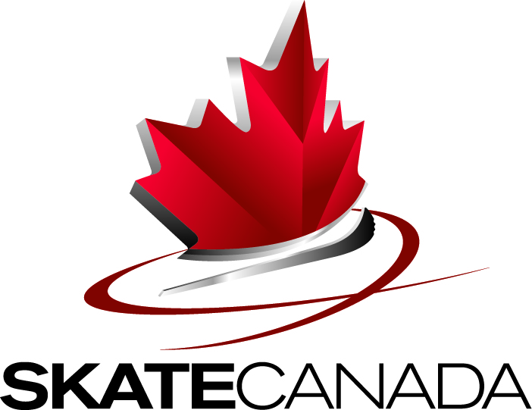 | Planned Program Content - Synchro

Section/ Club:
Category:
Name of Team:

ELEMENTS IN ORDER OF SKATING

Time* | Elements SP |  | Time* | Elements FS

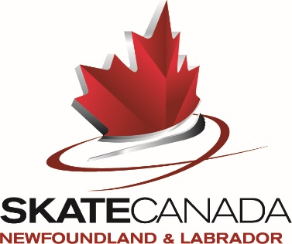 APPENDIX D
2018 Skate Canada Newfoundland and Labrador
Synchronized Skating Championships
Registration Instructions
- Set up an Account: *NOTE: If you already have a Team Account, login and skip to Step 2.
- Go to the Skate Canada NL Registration website (https://skatenf.uplifterinc.com)
- Click “Login” on the top right hand corner of the page
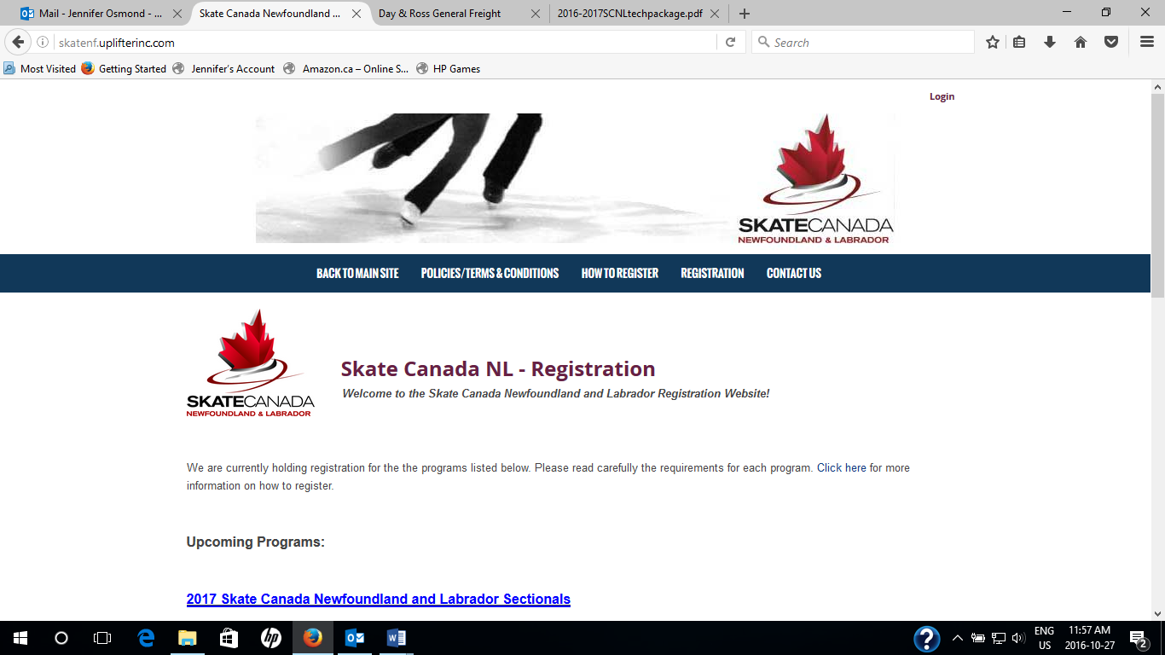
- Follow the instructions under “First Time Registering?” (RECOMMENDED) OR
- Login to an existing Skate Canada NL Uplifter account (only if the team is going to be registered as a participant under this profile)
- Enter the following:
  - Email Address – Team managers will either:
    - Create a new profile with a unique email address for their team (RECOMMENDED) OR
    - Add the team as a new participant under an existing Skate Canada NL Uplifter profile (login and under “My Account” enter the team as a new participant)
  - First Name – Enter the “Home Club”
  - Last Name – Enter the “Category” and “ Team Name”
  - If you have created a unique profile for your team click on “I will be registering myself into programs” Note: You will not need to fill in any of the additional information requested
  - At the bottom of the page click “Yes” to subscribe to all message lists to receive important information/updates regarding the competition.

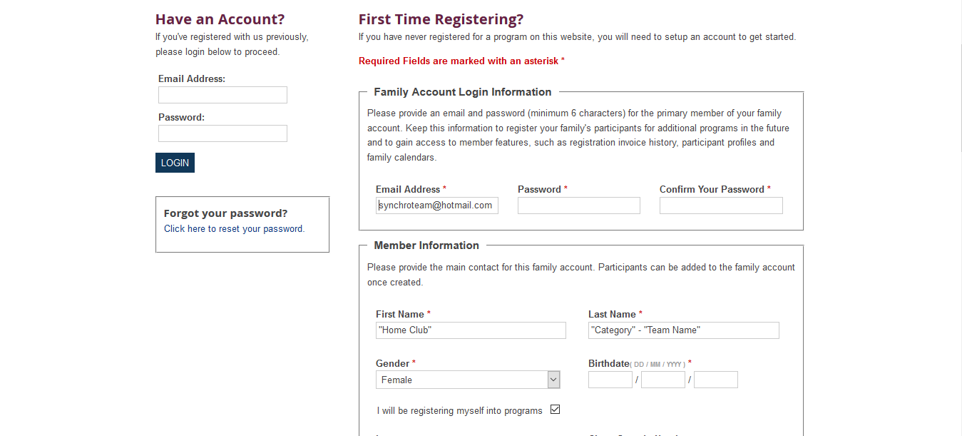
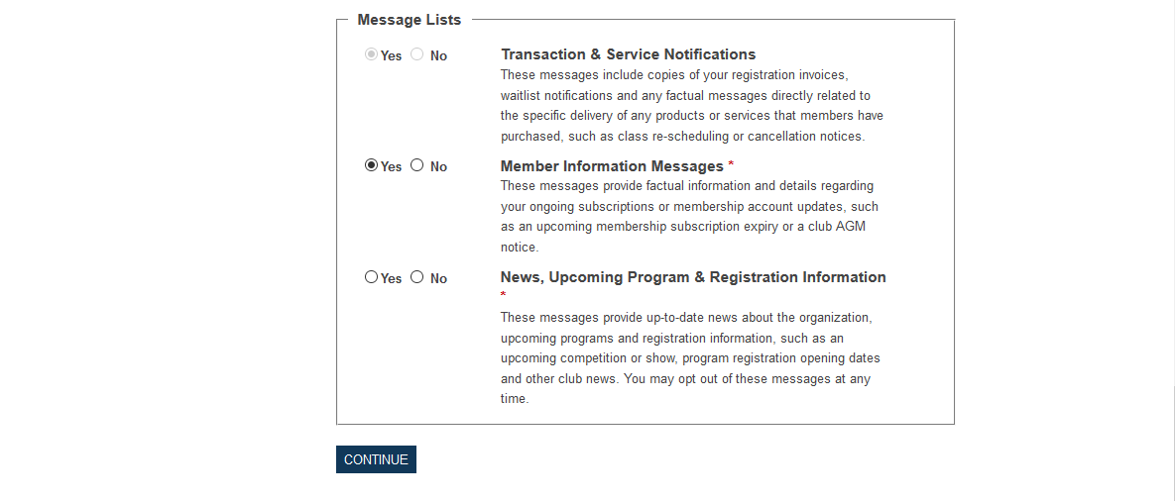
- Once you have set up your account, you will be brought back to the main page of the registration site.

- Complete Team and Skater Registration
- Click the “Registration” tab

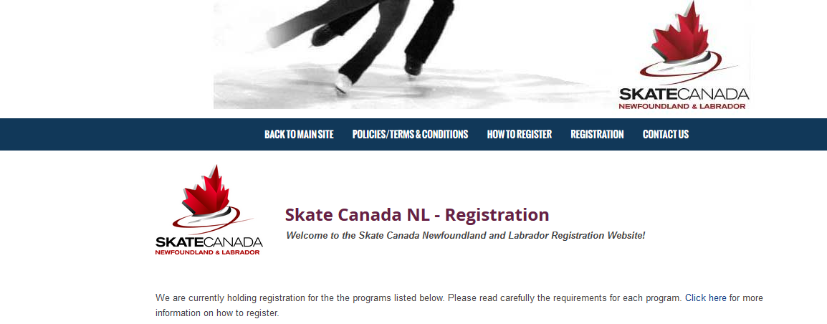

- Under “Quick Search”, enter your category (ie: Elementary)
- Select the option desired by clicking the REGISTER button assigned to that option. A box will appear asking you to choose the participant for this program.
- Click on “Shopping Cart” to complete the Team Registration.
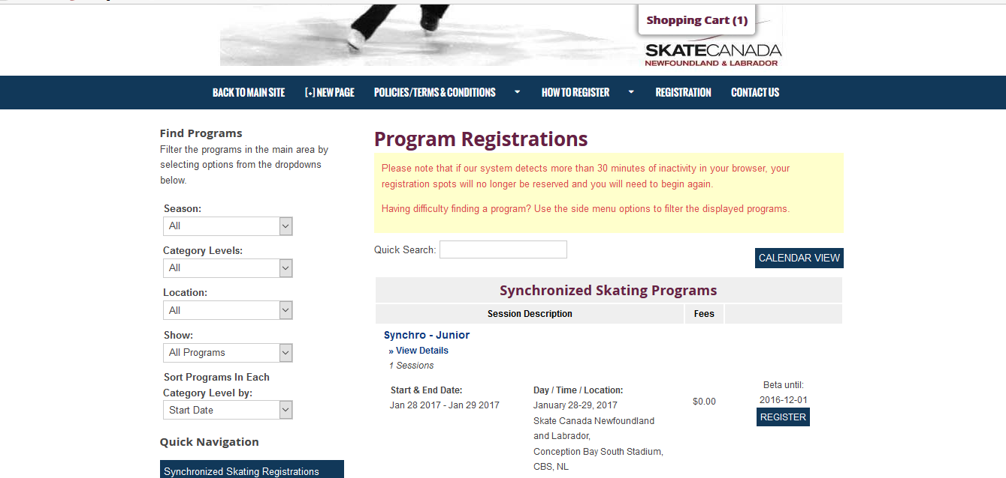
- Click on “Purchase other Products” to complete the Skater Registration.

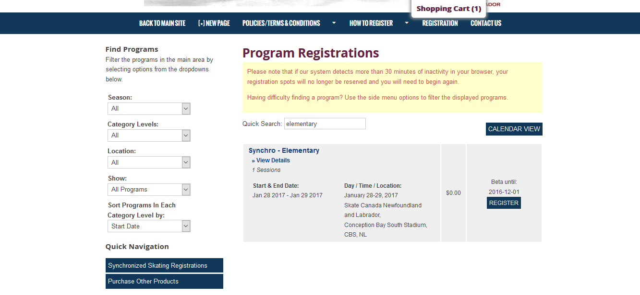

- Under “Items for Purchase”, Synchro Skater Registration enter the number of skaters on the team in the “QTY” box, click “Add to Cart”.

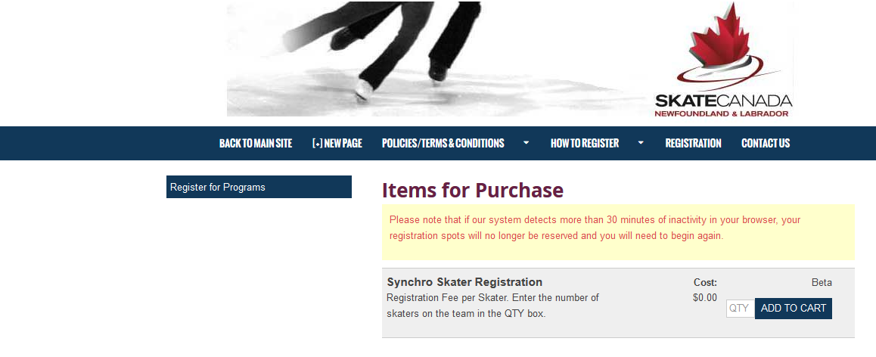

- In your Shopping Cart, click "Confirm & Register"

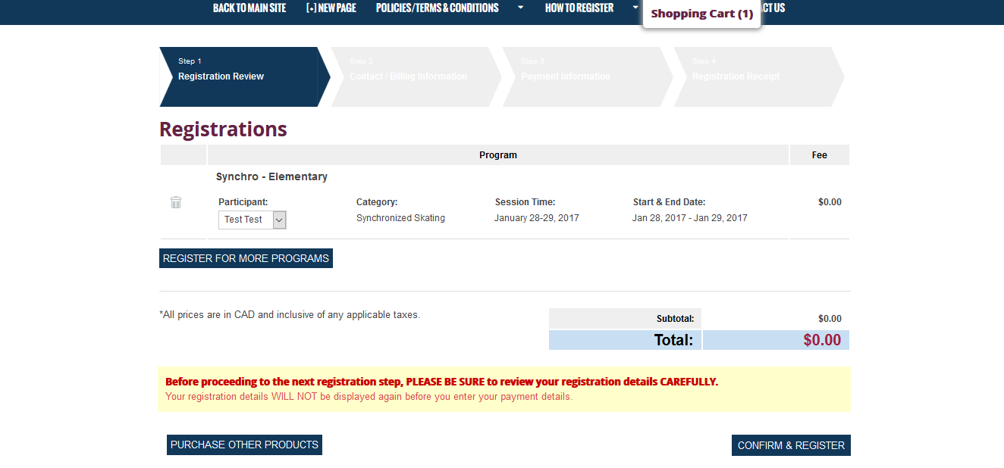

- You will be taken to a page indicating your payment options. After you have completed the payment process, you will receive an electronic invoice via email.

- Submit Additional Information

- Any additional documents/information, including merchandise information etc., will also be sent via email after the deadline for registration has passed.

If you have any questions or experience any problems, please contact Jennifer Osmond at scnljennifer@sportnl.ca or 709-576-0509.

